Part I: Foundational Issues
Chapter 1 Desktop Technologies
Chapter 2 Segmenting LANs
Chapter 3 Bridging Technologies
Chapter 4 Configuring The Catalyst
Chapter 5 VLANs

Chapter 1. Desktop Technologies
This chapter covers the following key topics:
- Legacy Ethernet—
This section explains the operations and implementation rules of legacy 10 Mbps CSMA/CD systems.
- LAN Frames—
This section presents various common formats for transporting packets over Ethernet.
- Fast Ethernet—
A now popular desktop Ethernet migration, this uses 100 Mbps technology. This section describes its characteristics and some of the common media options.
- Gigabit Ethernet—
As the highest speed Ethernet available today, this technology finds immediate utility for trunking Catalysts and connecting high performance servers. This section describes media options and characteristics.
- Token Ring—
Token Ring, the other popular LAN alternative, operates very differently from Ethernet. This section provides a brief overview of Token Ring.
Since the inception of local-area networks (LANs) in the 1970s, numerous LAN technologies graced the planet at one point or another. Some technologies became legends: ArcNet and StarLAN, for example. Others became legacies: Ethernet, Token Ring, and FDDI. ArcNet was the basis for some of the earliest office networks in the 1980s, because Radio Shack sold it for its personal computer line, Model II. A simple coaxial-based network, it was easy to deploy by office administrators for a few workstations. StarLAN, one of the earliest twisted-pair network technologies, became the basis for the Institute of Electrical and Electronic Engineers (IEEE) 10BaseT network. Running at 1 Mbps, StarLAN demonstrated that networking over twisted pair was feasible. Both ArcNet and StarLAN enjoyed limited success in the market because higher speed technologies such as 10 Mbps Ethernet and 4 Mbps Token Ring were introduced soon afterwards. With the higher bandwidth capacity of newer network technologies and the rapid development of higher speed workstations demanding more network bandwidth, ArcNet (now fondly referred to as ArchaicNet) and StarLAN were doomed to limited market presence.
The legacy networks continue to find utility as distribution and backbone technologies for both manufacturing and office environments. But like ArcNet and StarLAN, even these technologies see higher speed networks such as Fast Ethernet, High Speed Token Ring, and ATM crowding into the network arena. However, the legacy systems will remain for many more years due to the existence of such a large installed base. Users will replace Ethernet and Token Ring in phases as applications demand more bandwidth.
This chapter discusses the legacy network technologies, Ethernet and Token Ring, as well as Fast Ethernet and Gigabit Ethernet. Although Gigabit Ethernet is not yet a popular desktop technology, it is discussed here because of its relationship to Ethernet and its use in Catalyst networks for trunking Catalysts together. This chapter also describes how the access methods operate, some of the physical characteristics of each, and various frame formats and address types.

Legacy Ethernet
When mainframe computers dominated the industry, user terminals attached either directly to ports on the computer or to a controller that gave the appearance of a direct connection. Each wire connection was dedicated to an individual terminal. Users entered data, and the terminal immediately transmitted signals to the host. Performance was driven by the horsepower in the hosts. If the host became overworked, users experienced delays in responses. Note, though, that the connection between the host and terminal was not the cause in the delay. The users had full media bandwidth on the link regardless of the workload of the host device.
Facility managers installing the connections between the terminal and the host experienced distance constraints imposed by the host's terminal line technology. The technology limited users to locations that were a relatively short radius from the host. Further, labor to install the cables created inflated installation and maintenance expenses. Local-area networks (LANs) mitigated these issues to a large degree. One of the immediate benefits of a LAN was to reduce the installation and maintenance costs by eliminating the need to install dedicated wires to each user. Instead, a single cable pulled from user to user allowed users to share a common infrastructure instead of having dedicated infrastructures for each station.
A technology problem arises when users share a cable, though. Specifically, how does the network control who uses the cable and when? Broadband technologies like cable television (CATV) support multiple users by multiplexing data on different channels (frequencies). For example, think of each video signal on a CATV system as a data stream. Each data stream is transported over its own channel. A CATV system carries multiple channels on a single cable and can, therefore, carry multiple data streams concurrently. This is an example of frequency-division multiplexing (FDM). The initial LANs were conceived as baseband technologies, however, which do not have multiple channels. Baseband technologies do not transmit using FDM. Rather, they use bandwidth-sharing, which simply means that users take turns transmitting.
Ethernet and Token Ring define sets of rules known as access methodsfor sharing the cable. The access methods approach media sharing differently, but have essentially the same end goal in mind.

Carrier Sense with Multiple Access with Collision Detection (CSMA/CD)
Carrier sense multiple access collision detect (CSMA/CD) describes the Ethernet access method. CSMA/CD follows rules similar to those in a meeting. In a meeting, all individuals have the right to speak. The unspoken rule that all follows, though, is "Only one person can talk at a time." If you have something to say, you need to listen to see if someone is speaking. If someone is already speaking, you must wait until they are finished. When you start to speak, you need to continue to listen in case someone else decides to speak at the same time. If this happens, both parties must stop talking and wait a random amount of time. Only then do they have the right to start the process again. If individuals fail to observe the protocol of only one speaker at a time, the meeting quickly degenerates and no effective communication occurs. (Unfortunately, this happens all too often.)
In Ethernet, multiple access is the terminology for many stations attaching to the same cable and having the opportunity to transmit. No station has any priority over any other station. However, they do need to take turns per the access algorithm.
Carrier sense refers to the process of listening before speaking. The Ethernet device wishing to communicate looks for energy on the media (an electrical carrier). If a carrier exists, the cable is in use and the device must wait to transmit. Many Ethernet devices maintain a counter of how often they need to wait before they can transmit. Some devices call the counter a deferral or back-off counter. If the deferral counter exceeds a threshold value of 15 retries, the device attempting to transmit assumes that it will never get access to the cable to transmit the packet. In this situation, the source device discards the frame. This might happen if there are too many devices on the network, implying that there is not enough bandwidth available. When this situation becomes chronic, you should segment the network into smaller segments. Chapter 2, "Segmenting LANs," discusses various approaches to segmentation. If the power level exceeds a certain threshold, that implies to the system that a collision occurred. When stations detect that a collision occurs, the participants generate a collision enforcement signal . The enforcement signal lasts as long as the smallest frame size. In the case of Ethernet, that equates to 64 bytes. This ensures that all stations know about the collision and that no other station attempts to transmit during the collision event. If a station experiences too many consecutive collisions, the station stops transmitting the frame. Some workstations display an error message stating Media not available . The exact message differs from implementation to implementation, but every workstation attempts to convey to the user that it was unable to send data for one reason or another.

Addressing in Ethernet
How do stations identify each other? In a meeting, you identify the intended recipient by name. You can choose to address the entire group, a set of individuals, or a specific person. Speaking to the group equates to a broadcast; a set of individuals is a multicast; and addressing one person by name is a unicast. Most traffic in a network is unicast in nature, characterized as traffic from a specific station to another specific device. Some applications generate multicast traffic. Examples include multimedia services over LANs. These applications intend for more than one station to receive the traffic, but not necessarily all for all stations. Video conferencing applications frequently implement multicast addressing to specify a group of recipients. Networking protocols create broadcast traffic, whereas IP creates broadcast packets for ARP and other processes. Routers often transmit routing updates as broadcast frames, and AppleTalk, DecNet, Novell IPX, and many other protocols create broadcasts for various reasons.
Figure 1-1 shows a simple legacy Ethernet system with several devices attached. Each device's Ethernet adapter card has a 48-bit (6 octet) address built in to the module that uniquely identifies the station. This is called the Media Access Control (MAC) address, or the hardware address. All of the devices in a LAN must have a unique MAC address. Devices express MAC addresses as hexadecimal values. Sometimes MAC address octets are separated by hyphens (-) sometimes by colons (:) and sometimes periods (.). The three formats of 00-60-97-8F-4F-86, 00:60:97:8F:4F:86, and 0060.978F.4F86 all specify the same host. This book usually uses the first format because most of the Catalyst displays use this convention; however, there are a couple of exceptions where you might see the second or third format. Do not let this confuse you. They all represent MAC addresses.

Figure 1-1 A Simple Ethernet Network
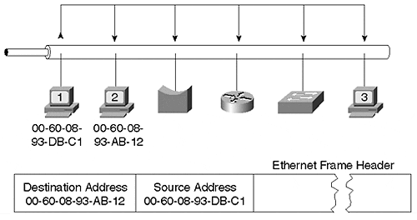
To help ensure uniqueness, the first three octets indicate the vendor who manufactured the interface card. This is known as the Organizational Unique Identifier (OUI). Each manufacturer has a unique OUI value that it acquired from IEEE, the global administrator for OUI values. Cisco has several OUI values: 00000C, 00067C, 0006C1, 001007, 00100B, 00100D, 001011, 001014, 00101F, 001029, 00102F, 001054, 001079, 00107B, 0010A6, 0010F6, 0010FF, 00400B (formerly Crescendo), 00500F, 005014, 00502A, 00503E, 005050, 005053, 005054, 005073, 005080, 0050A2, 0050A7, 0050BD, 0050E2, 006009, 00602F, 00603E, 006047, 00605C, 006070, 006083, 00900C, 009021, 00902B, 00905F, 00906D, 00906F, 009086, 009092, 0090A6, 0090AB, 0090B1, 0090BF, 0090D9, 0090F2, 00D006, 00D058, 00D0BB, 00D0C0, 00E014, 00E01E, 00E034, 00E04F, 00E08F, 00E0A3, 00E0B0, 00E0F7, 00E0F9,and 00E0FE.
The last three octets of the MAC address equate to a host identifier for the device. They are locally assigned by the vendor. The combination of OUI and host number creates a unique address for that device. Each vendor is responsible to ensure that the devices it manufactures have a unique combination of 6 octets.

Unicast Frames
In a LAN, stations must use the MAC address for the Layer 2 address in a frame to identify the source and destination. When Station 1 transmits to Station 2 in Figure 1-1, Station 1 generates a frame that includes Station 2's MAC address (00-60-08-93-AB-12) for the destination and Station 1's address (00-60-08-93-DB-C1) for the source. This is a unicast frame. Because the LAN is a shared media, all stations on the network receive a copy of the frame. Only Station 2 performs any processing on the frame, though. All stations compare the destination MAC address with their own MAC address. If they do not match, the station's interface module discards (ignores) the frame. This prevents the packet from consuming CPU cycles in the device. Station 2, however, sees a match and sends the packet to the CPU for further analysis. The CPU examines the network protocol and the intended application and decides whether to drop or use the packet.

Broadcast Frames
Not all frames contain unicast destination addresses. Some have broadcast or multicast destination addresses. Stations treat broadcast and multicast frames differently than they do unicast frames. Stations view broadcast frames as public service announcements. When a station receives a broadcast, it means, "Pay attention! I might have an important message for you!" A broadcast frame has a destination MAC address of FF-FF-FF-FF-FF-FF (all binary 1s). Like unicast frames, all stations receive a frame with a broadcast destination address. When the interface compares its own MAC address against the destination address, they don't match. Normally, a station discards the frame because the destination address does not match its own hardware address. But broadcast frames are treated differently. Even though the destination and built-in address don't match, the interface module is designed so that it still passes the broadcast frame to the processor. This is intentional because designers and users want to receive the broadcast frame as it might have an important request or information. Unfortunately, probably only one or at most a few stations really need to receive the broadcast message. For example, an IP ARP request creates a broadcast frame even though it intends for only one station to respond. The source sends the request as a broadcast because it does not know the destination MAC address and is attempting to acquire it. The only thing the source knows for sure when it creates the ARP request is the destination's IP address. That is not enough, however, to address the station on a LAN. The frame must also contain the MAC address.
Routing protocols sometimes use broadcast MAC addresses when they announce their routing tables. For example, by default, routers send IP RIP updates every 30 seconds. The router transmits the update in a broadcast frame. The router does not necessarily know all of the routers on the network. By sending a broadcast message, the router is sure that all routers attached to the network will receive the message. There is a downside to this, however. All devices on the LAN receive and process the broadcast frame, even though only a few devices really needed the updates. This consumes CPU cycles in every device. If the number of broadcasts in the network becomes excessive, workstations cannot do the things they need to do, such as run word processors or flight simulators. The station is too busy processing useless (for them) broadcast frames.

Multicast Frames
Multicast frames differ from broadcast frames in a subtle way. Multicast frames address a group of devices with a common interest and allow the source to send only one copy of the frame on the network, even though it intends for several stations to receive it. When a station receives a multicast frame, it compares the multicast address with its own address. Unless the card is previously configured to accept multicast frames, the multicast is discarded on the interface and does not consume CPU cycles. (This behaves just like a unicast frame.)
For example, Cisco devices running the Cisco Discovery Protocol (CDP) make periodic announcements to other locally attached Cisco devices. The information contained in the announcement is only interesting to other Cisco devices (and the network administrator). To transfer the announcement, the Cisco source could send a unicast to each and every Cisco device. That, however, means multiple transmissions on the segment and consumes network bandwidth with redundant information. Further, the source might not know about all of the local Cisco devices and could, therefore, choose to send one broadcast frame. All Cisco devices would receive the frame. Unfortunately, so would all non-Cisco devices. The last alternative is a multicast address. Cisco has a special multicast address reserved, 01-00-0C-CC-CC-CC, which enables Cisco devices to transmit to all other Cisco devices on the segment. All non-Cisco devices ignore this multicast message.
Open Shortest Path First (OSPF), an IP routing protocol, makes routing update announcements on a specially reserved multicast address. The reserved multicast OSPF IP addresses 224.0.0.5 and 224.0.0.6 translate to MAC multicast addresses of 01-00-5E-00-00-05 and 01-00-5E-00-00-06. Chapter 13, "Multicast and Broadcast Services," discusses how these MAC addresses are derived. Only routers interested in receiving the OSPF announcement configure their interface to receive the message. All other devices filter the frame.

LAN Frames
When stations transmit to each other on a LAN, they format the data in a structured manner so that devices know what octets signify what information. Various frame formats are available. When you configure a device, you must define what format your station will use, realizing that more than one format might be configured, as is true for a router.
Figure 1-2 illustrates four common frame formats for Ethernet. Some users interchange the terms packets and frames rather loosely. According to RFC 1122, a subtle difference exists. Frames refer to the entire message, from the data link layer (Layer 2) header information through and including the user data. Packets exclude Layer 2 headers and only include the IP header (Layer 3 protocol header) through and including user data.

Figure 1-2 Four Ethernet Frame Formats
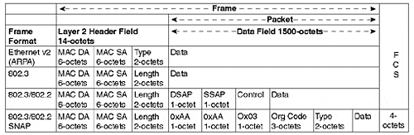
The frame formats developed as the LAN industry evolved and differing requirements arose for protocols. When XEROX developed the original Ethernet (which was later adopted by the industry), a frame format like the Ethernet frame in Figure 1-2 was defined. The first 6 octets contain the destination's MAC address, whereas the next field of 6 octets contain the source's MAC address. Two bytes follow that indicate to the receiver the correct Layer 3 protocol to which the packet belongs. For example, if the packet belongs to IP, then the type field value is 0x0800. Table 1-1 lists several common protocols and their associated type values.

Table 1-1. Common Routed Protocols and Their Hex Type Values
Protocol | Hex Type Value
IP | 0800
ARP | 0806
Novell IPX | 8137
AppleTalk | 809B
Banyan Vines | 0BAD
802.3 | 0000-05DC
Following the type value, the receiver expects to see additional protocol headers. For example, if the type value indicates that the packet is IP, the receiver expects to decode IP headers next. If the value is 8137, the receiver tries to decode the packet as a Novell packet.
IEEE defined an alternative frame format. In the IEEE 802.3 formats, the source and destination MAC addresses remain, but instead of a type field value, the packet length is indicated. Three derivatives to this format are used in the industry: raw 802.3, 802.3 with 802.2 LLC, and 802.3 with 802.2 and SNAP. A receiver recognizes that a packet follows 802.3 formats rather than Ethernet formats by the value of the two-byte field following the source MAC address. If the value falls within the range of 0x0000 and 0x05DC (1500 decimal), the value indicates length; protocol type values begin after 0x05DC.

Ethernet SlotTimes
Ethernet's rules govern how stations operate in a CSMA/CD environment. The rules constantly keep in mind the need to detect collisions and to report them to the participants. Ethernet defines a slotTime wherein a frame travels from one network extreme to the other. In Figure 1-3, assume that Station 1, located at one extreme of the network, transmits a frame. Just before the frame reaches Station 2, located at the other extreme of the network, Station 2 transmits. Station 2 transmits because it has something to send, and because Station 1's frame hasn't arrived yet, Station 2 detects silence on the line. This demonstrates a prime example of a collision event between devices at opposite extremes of the network. Because they are at opposite ends of the network, the timing involves worst case values for detecting and reporting collisions.

Figure 1-3 A Worst Case Collision Example
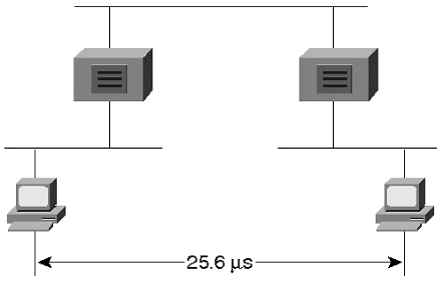
Ethernet rules state that a station must detect and report collisions between the furthest points in the network before the source completes its frame transmission. Specifically, for a legacy 10 Mbps Ethernet, this must all occur within 51.2 microseconds. Why 51.2 microseconds? The time is based on the smallest frame size for Ethernet, which corresponds to the smallest time window to detect and report collisions. The minimum frame size for Ethernet is 64 bytes, which has 512 bits. Each bit time is 0.1 microseconds in length, which is calculated from one over Ethernet's data rate (1/10⁶). Therefore, the slot time for Ethernet is 0.1 microseconds/bit × 512 bits or 51.2 microseconds.
Next, the Ethernet specification translates the slotTime into distance. As the Ethernet signal propagates through the various components of the collision domain, time delays are introduced. Time delay values are calculated for copper cables, optical fibers, and repeaters. The amount of delay contributed by each component varies based upon the media characteristics. A correctly designed network topology totals the delay contribution for each component between the network extremes and ensures that the total is less than one half of 51.2 microseconds. This guarantees that Station 2 can detect the collision and report it to Station 1 before Station 1 completes the transmission of the smallest frame.
A network that violates the slotTime rules by extending the network to distances that require more than 51.2 microseconds experience late collisions, which can cause the network to malfunction. When a station transmits, it retains the frame in a local buffer until it either transmits the frame successfully (that is, without a collision) or the deferral counter threshold is exceeded. We previously discussed the deferral counter situation. Assume that a network administrator overextends the network in Figure 1-3 by inserting too many repeaters or by deploying segments that are too long. When Station 1 transmits, it assumes that the frame successfully transmitted if it experiences no collision by the time that it transmits 64 octets. Once the frame believes that it was successfully transmitted, the frame is eliminated from buffers leaving no opportunity to retry. When the network overextends the slotTime, the source might learn of a collision after it transmits the first 64 octets. But no frame is in the buffer at this point to resend, because the source thought that the transmission was successful!

Ethernet Frame Rates/Performance
Debates rage over Ethernet performance. Specifically, network administrators focus on the question, "What is the average loading that should be supported on a network?" Some administrators claim that the network load should not exceed about 30 percent of the available bandwidth. Some state as high as 50 percent. The answer really depends upon your users' application needs. At what point do users complain? When it is most inconvenient for you to do anything about it, of course! Networks rarely support a sustained loading over 50 percent due to bandwidth loss from collisions. Collisions consume bandwidth and force stations to retransmit, consuming even more bandwidth. If the network were collisionless, up to 100 percent utilization could be achieved. This is not likely.
To provide some guidelines though, consider the theoretical frame rates for Ethernet. Frame rates depend upon the size of the frame. To calculate the packets per second for various frame sizes, use the following formula:
Packets/second = 1 second/(IFG + PreambleTime + FrameTime)
where:
- Inter Frame Gap (IFG) is equal to the amount of time required between each frame. This is specified as 9.6 microseconds.
- PreambleTime is equal to the number of microseconds to transmit the 64-bit preamble. This is 6.4 microseconds.
- FrameTime is equal to the number of microseconds to transmit the frame. For a 64-octet frame, this is 51.2 microseconds.
The packet per second (pps) rate for a 64-octet frame is, therefore, as follows:
1 second/(9.6 + 6.4 + 51.2) microseconds per packet = 14,880 pps
At the other extreme, consider the pps rate for the largest frame size, 1,518 octets:
1 second/(9.6 + 6.4 + 1,214.4) microseconds per packet = 812 pps
A 30 percent average loading implies that a network analyzer measures about 3 Mbps of sustained traffic on the system. This in and of itself is not enough to determine how well or how poorly the network is functioning. What size packets are creating the load? Usually numerous packet sizes are involved. How many collisions are there on the network? If there are few, only some of the stations are transmitting. This might provide a clue for you that more transmitters can be supported on the network. In any event, a good measurement is needed of your network and what users perceive the current network response to be.

Fast Ethernet
When Ethernet technology availed itself to users, the 10 Mbps bandwidth seemed like an unlimited resource. (Almost like when we had 640k of PC RAM…it seemed we would never need more!) Yet workstations have developed rapidly since then, and applications demand more data in shorter amounts of time. When the data comes from remote sources rather than from a local storage device, this amounts to the application needing more network bandwidth. New applications find 10 Mbps to be too slow. Consider a surgeon downloading an image from a server over a 10 Mbps shared media network. He needs to wait for the image to download so that he can begin/continue the surgery. If the image is a high resolution image, not unusually on the order of 100 MB, it could take a while to receive the image. What if the shared network makes the available user bandwidth about 500 kbps (a generous number for most networks) on the average? It could take the physician 26 minutes to download the image:
100 MB × 8/500 kbps = 26 minutes
If that were you on the operating table waiting for the image to download, you would not be very happy! If you are the hospital administration, you are exposing yourself to surgical complications at worst and idle physician time at best. Obviously, this is not a good situation. Sadly, many hospital networks function like this and consider it normal. Clearly, more bandwidth is needed to support this application.
Recognizing the growing demand for higher speed networks, the IEEE formed the 802.3u committee to begin work on a 100 Mbps technology that works over twisted-pair cables. In June of 1995, IEEE approved the 802.3u specification defining a system that offered vendor interoperability at 100 Mbps.
Like 10 Mbps systems such as 10BaseT, the 100 Mbps systems use CSMA/CD, but provide a tenfold improvement over legacy 10 Mbps networks. Because they operate at 10 times the speed of 10 Mbps Ethernet, all timing factors reduce by a factor of 10. For example, the slotTime for 100 Mbps Ethernet is 5.12 microseconds rather than 51.2 microseconds. The IFG is .96 microseconds. And because timing is one tenth that of 10 Mbps Ethernet, the network diameter must also shrink to avoid late collisions.
An objective of the 100BaseX standard was to maintain a common frame format with legacy Ethernet. Therefore, 100BaseX uses the same frame sizes and formats as 10BaseX. Everything else scales by one tenth due to the higher data rate. When passing frames from a 10BaseX to a 100BaseX system, the interconnecting device does not need to re-create the frame's Layer 2 header because they are identical on the two systems.
10BaseT, the original Ethernet over twisted-pair cable standard, supports Category 3, 4, and 5 cables up to 100 meters in length. 10BaseT uses a single encoding technique, Manchester, and signals at 20 MHz well within the bandwidth capability of all three cable types. Because of the higher signaling rate of 100BaseT, creating a single method to work over all cable types was not likely. The encoding technologies that were available at the time forced IEEE to create variants of the standard to support Category 3 and 5 cables. A fiber optic version was created as well.

Full-Duplex and Half-Duplex Support
This chapter began with discussions on legacy Ethernet and CSMA/CD. Legacy Ethernet uses CSMA/CD because it operates on a shared media where only one device can talk at a time. When a station talks, all other devices must listen or else the system experiences a collision. In a 10 Mbps system, the total bandwidth available is dedicated to transmitting or receiving depending upon whether the station is the source or the recipient. This describes half duplex.
The original LAN standards operate in half-duplex mode allowing only one station to transmit at a time. This was a side effect of the bus topology of 10Base5 and 10Base2 where all stations attached to the same cable. With the introduction of 10BaseT, networks deployed hubs and attached stations to the hub on dedicated point-to-point links. Stations do not share the wire in this topology. 100BaseX uses hubs with dedicated point-to-point links. Because each link is not shared, a new operational mode becomes feasible. Rather than running in half-duplex mode, the systems can operate in full-duplex mode, which allows stations to transmit and receive at the same time, eliminating the need for collision detection. What advantage does this provide? The tremendous asset of the precious network commodity—bandwidth. When a station operates in full-duplex mode, the station transmits and receives at full bandwidth in each direction.
The most bandwidth that a legacy Ethernet device can expect to enjoy is 10 Mbps. It either listens at 10 Mbps or transmits at 10 Mbps. In contrast, a 100BaseX device operating in full-duplex mode sees 200 Mbps of bandwidth—100 Mbps for transmitting and 100 Mbps for receiving. Users upgraded from 10BaseT to 100BaseX have the potential to immediately enjoy a twentyfold, or more, bandwidth improvement. If the user previously attached to a shared 10 Mbps system, they might only practically enjoy a couple megabits per second of effective bandwidth. Upgrading to a full duplex 100 Mbps system might provide a perceived one hundredfold improvement. If your users are unappreciative of the additional bandwidth, you have an unenviable group of colleagues with which to work. Put them back on 10BaseT!
Note
Be aware, however: Just because an interface card runs 100BaseX full duplex, you cannot assume that the device where you install it supports full-duplex mode. In fact, some devices might actually experience worse throughput when in full-duplex mode than when in half-duplex mode. For example, Windows NT 4.0 does not support full-duplex operations because of driver limitations. Some SUN workstations can also experience this, especially with Gigabit Ethernet.

The IEEE 802.3x committee designed a standard for full-duplex operations that covers 10BaseT, 100BaseX, and 1000BaseX. (1000BaseX is Gigabit Ethernet discussed in a later section, "Gigabit Ethernet.") 802.3x also defined a flow control mechanism. This allows a receiver to send a special frame back to the source whenever the receiver's buffers overflow. The receiver sends a special packet called a pause frame. In the frame, the receiver can request the source to stop sending for a specified period of time. If the receiver can handle incoming traffic again before the timer value in the pause frame expires, the receiver can send another pause frame with the timer set to zero. This tells the receiver that it can start sending again.
Although 100BaseX supports both full- and half-duplex modes, you can deploy 100 Mbps hubs that operate in half-duplex mode. That means the devices attached to the hub share the bandwidth just like the legacy Ethernet systems. In this case, the station must run in half-duplex mode. To run in full-duplex mode, the device and the hub (switch) must both support and be configured for full duplex. Note that you cannot have a full duplex for a shared hub. If the hub is shared, it must operate in half-duplex mode.

Autonegotiation
With the multiple combinations of network modes available, configuring devices gets confusing. You need to determine if the device needs to operate at 10 or 100 Mbps, whether it needs to run in half- or full-duplex mode, and what media type to use. The device configuration must match the hub configuration to which it attaches.
Autonegotiation attempts to simplify manual configuration requirements by enabling the device and hub to automatically agree upon the highest common operational level. The 802.3u committee defined Fast Link Pulse (FLP) to support the autonegotiation process. FLP, an enhanced version of 10BaseT's Link Integrity Test, sends a series of pulses on the link announcing its capabilities. The other end also transmits FLP announcements, and the two ends settle on whatever method has highest priority in common between them. Table 1-2 illustrates the priority scheme.

Table 1-2. Autonegotiation Prioritization
Priority | Method
1 | 100BaseT2 full duplex
2 | 100BaseT2 half duplex
3 | 100BaseTX full duplex
4 | 100BaseT4 (Only half duplex)
5 | 100BaseTX half duplex
6 | 10BaseT full duplex
7 | 10BaseT half duplex
According to Table 1-2, 100BaseT2 full-duplex mode has highest priority, whereas the slowest method, 10BaseT half-duplex, has lowest priority. Priority is determined by speed, cable types supported, and duplex mode. A system always prefers 100 Mbps over 10 Mbps, and always prefers full duplex over half duplex. Note that 100BaseT2 has higher priority than 100BaseTX. This is not a direct result of 100BaseT2 being a more recent medium. Rather, 100BaseT2 has higher priority because it supports more cable types than does 100BaseTX. 100BaseTX only supports Category 5 type cable, whereas 100BaseT2 supports Category 3, 4, and 5 cables.
Tip
Not all devices perform autonegotiation. We have observed at several customer locations failure of the autonegotiation process—either because of equipment not supporting the feature or poor implementations. We recommend that critical devices such as routers, switches, bridges, and servers be manually configured at both ends of the link to ensure that, upon reboot, the equipment operates in a common mode with its hub/switch port.

100BaseTX
Many existing 10 Mbps twisted-pair systems use a cabling infrastructure based upon Category 5 (unshielded twisted-pair) UTP and (shielded twisted-pair) STP. The devices use two pairs of the cable: one pair on pins 1 and 2 for transmit and one pair on pins 3 and 6 for receive and collision detection. 100BaseTX also uses this infrastructure. Your existing Category 5 cabling for 10BaseT should support 100BaseTX, which also implies that 100BaseTX works up to 100 meters, the same as 10BaseT.
100BaseTX uses an encoding scheme like Fiber Distributed Data Interface (FDDI) of 4B/5B. This encoding scheme adds a fifth bit for every four bits of user data. That means there is a 25 percent overhead in the transmission to support the encoding. Although 100BaseTX carries 100 Mbps of user data, it actually operates at 125 Megabaud. (We try not to tell this to marketing folks so that they do not put on their data sheets 125 Mbps throughput!)

100BaseT4
Not all building infrastructures use Category 5 cable. Some use Category 3. Category 3 cable was installed in many locations to support voice transmission and is frequently referred to as voice grade cable. It is tested for voice and low speed data applications up to 16 MHz. Category 5 cable, on the other hand, is intended for data applications and is tested at 100 MHz. Because Category 3 cable exists in so many installations, and because many 10BaseT installations are on Category 3 cable, the IEEE 802.3u committee included this as an option. As with 10BaseT, 100BaseT4 links work up to 100 meters. To support the higher data rates, though, 100BaseT4 uses more cable pairs. Three pairs support transmission and one pair supports collision detection. Another technology aspect to support the high data rates over a lower bandwidth cable comes from the encoding technique used for 100BaseT4. 100BaseT4 uses an encoding method of 8B/6T (8 bits/6 ternary signals) which significantly lowers the signaling frequency, making it suitable for voice-grade wire.

100BaseT2
Although 100BaseT4 provides a solution for Category 3 cable, it needs four pairs to support operations. Most Category 3 cable installations intend for the cable to support voice communications. By consuming all the pairs in the cable for data transmissions, no pairs remain to support voice communications. 100BaseT2, completed by IEEE in 1997 and called 802.3y, operates on Category 3, 4, and 5 cables and only requires two cable pairs. A new addition to the 100BaseT standards, 100BaseT2 relies upon advanced digital signal processing chips and encoding methods called PAM 5x5 (4 bits point to one of 25 possible values) to function over the lower bandwidth cable type. 100BaseT2 works on link lengths up to 100 meters.

100BaseFX
802.3u specifies a variant for single-mode and multimode fiber optic cables. 100BaseFX uses two strands (one pair) of fiber optic cables—one for transmitting and one for receiving. Like 100BaseTx, 100BaseFX uses a 4B/5B encoding signaling at 125 MHz on the optical fiber. When should you use the fiber optic version? One clear situation arises when you need to support distances greater than 100 meters. Multimode supports up to 2,000 meters in full-duplex mode, 412 meters in half-duplex mode. Single-mode works up to 10 kms—a significant distance advantage. Other advantages of fiber include its electrical isolation properties. For example, if you need to install the cable in areas where there are high levels of radiated electrical noise (near high voltage power lines or transformers), fiber optic cable is best. The cable's immunity to electrical noise makes it ideal for this environment. If you are installing the system in an environment where lightning frequently damages equipment, or where you suffer from ground loops between buildings on a campus, use fiber. Fiber optic cable carries no electrical signals to damage your equipment.

Table 1-3. 100BaseX Media Comparisons
Standard | Cable Type | Mode | Pairs Required | Distance (meters)
10BaseT | Category 3,4,5 | Half Duplex | 2 | 100
100BaseTX | Category 5 | Half Duplex, Full Duplex | 2 | 100
100BaseT4 | Category 3 | Half Duplex | 4 | 100
100BaseT2 | Category 3,4,5 | Half Duplex, Full Duplex | 2 | 100
100BaseFX | Multimode | Half Duplex, Full Duplex | 1 | 412(Half-Duplex) 2000(Full-Duplex)
100BaseFX | Single-mode | Half Duplex, Full Duplex | 1 | 10 kms
Note that the multimode fiber form of 100BaseFX specifies two distances. If you run the equipment in half-duplex mode, you can only transmit 412 meters. Full-duplex mode reaches up to 2 kms.

Media-Independent Interface (MII)
When you order networking equipment, you usually order the system with a specific interface type. For example, you can purchase a router with a 100BaseTX connection. When you buy it with this kind of interface, the 100BaseTX transceiver is built in to the unit. This connection is fine, as long as you only attach it to another 100BaseTX device such as another workstation, hub, or switch. What if you decide at a later time that you need to move the router to another location, but the distance demands that you need to connect over fiber optics rather than over copper? You need to buy another module to replace the 100BaseTX that you previously installed. This can be costly.
An alternative is the MII connector. This is a 40-pin connector that allows you to connect an external transceiver that has an MII connection on one side and a 100BaseX interface on the other side. Functionally, it is similar to the AUI connector for 10 Mbps Ethernet and allows you to change the media type without having to replace any modules. Rather, you can change a less expensive media adapter (transceiver). For Fast Ethernet, if you decide to change the interface type, all you need to do is change the MII transceiver. This is potentially a much less expensive option than replacing an entire router module.

Network Diameter (Designing with Repeaters in a 100BaseX Network)
In a legacy Ethernet system, repeaters extend cable distances, allowing networks to reach further than the segment length. For example, a 10Base2 segment only reaches 185 meters in length. If an administrator desires to attach devices beyond this reach, the administrator can use repeaters to connect a second section of 10Base2 cable to the first. In a 10BaseT network, hubs perform the repeater functions allowing two 100 meter segments to connect together. Legacy repeaters are discussed in more detail in Chapter 2, "Segmenting LANs."
802.3u defines two classes of repeaters for 100BaseX systems. The two repeater classes differ in their latency which affects the network diameter supported. A Class I repeater latency is 0.7 microseconds or less, whereas a Class II repeater latency is 0.46 microseconds or less. Only one Class I repeater is allowed in a 100BaseX system, whereas two hops are permitted for Class II repeaters. Why are there two repeater classes?
Class I repeaters operate by converting the incoming signal from a port into an internal digital signal. It then converts the frame back into an analog signal when it sends it out the other ports. This allows a Class I repeater to have a mix of ports that are 100BaseTX, 100BaseT4, 100BaseT2 or 100BaseFX. Remember that the line encoding scheme for these methods differ. The only ones with a common encoding scheme, 4B/5B, are 100BaseTX and 100BaseFX. A Class I repeater can translate the line encoding to support the differing media types.
Class II repeaters, on the other hand, are not as sophisticated. They can only support ports with a same line encoding method. Therefore, if you are using 100BaseT4 cabling, all ports in a Class II repeater must be 100BaseT4. Similarly, if you are using 100BaseT2, all ports of your Class II repeater must be 100BaseT2. The only exception to mixing is for 100BaseTX and 100BaseFX, because these both use 4B/5B and no encoding translation is necessary.
The lower latency value for a Class II repeater enables it to support a slightly larger network diameter than a Class I based network. Converting the signal from analog to digital and performing line encoding translation consumes bit times. A Class I repeater therefore introduces more latency than a Class II repeater reducing the network diameter.
Figure 1-4 illustrates interconnecting stations directly together without the use of a repeater. Each station is referred to as a DTE (data terminal equipment) device. Transceivers and hubs are DCE (data communication equipment) devices. Use a straight through cable when connecting a DTE to a DCE device. Use a cross-over when connecting a DTE to DTE or a DCE to DCE. Either copper or fiber can be used. Be sure, however, that you use a cross-over cable in this configuration. A cross-over cable attaches the transmitter pins at one end to the receiver pins at the other end. If you use a straight through cable, you connect "transmit" at one end to "transmit" at the other end and fail to communicate. (The Link Status light does not illuminate!)

Figure 1-4 Interconnecting DTE to DTE
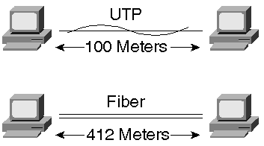
Note
There is an exception to this where you can, in fact, connect two DTE or two DCE devices directly together with a straight through cable. Some devices have MDI (medial interface) and MDIX ports. The MDIX is a media interface cross-over port. Most ports on devices are MDI. You can use a straight through cable when connecting from an MDI to an MDIX port.

Using a Class I repeater as in Figure 1-5 enables you to extend the distance between workstations. Note that with a Class I repeater you can mix the types of media attaching to the repeater. Any mix of 100BaseTX, 100BaseT4, 100BaseT2, or 100BaseFX works. Only one Class I repeater is allowed in the network. To connect Class I repeaters together, a bridge, switch, or router must connect between them.

Figure 1-5 Networking with Class I Repeaters
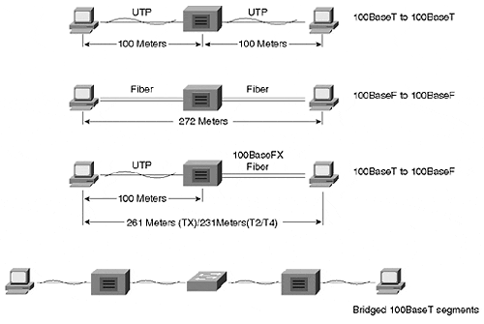
Class II repeaters demand homogenous cabling to be attached to them. If you use 100BaseT4, all ports must be 100BaseT4. The only mix permitted uses 100BaseTX and 100BaseFX. Figure 1-6 illustrates a network with only one Class II repeater.

Figure 1-6 Networking with one Class II Repeater
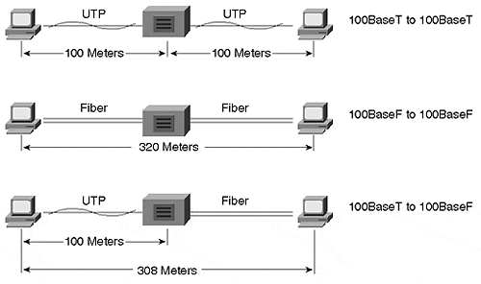
Unlike Class I repeaters, two Class II repeaters are permitted as in Figure 1-7. The connection between the repeaters must be less than or equal to five meters. Why daisy chain the repeaters if it only gains five meters of distance? Simply because it increases the number of ports available in the system.

Figure 1-7 Networking with Two Class II Repeaters
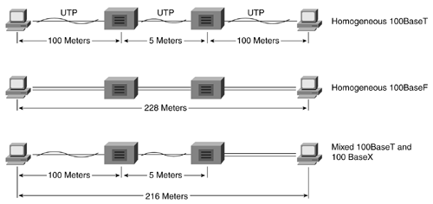
The networks in Figure 1-5 through Figure 1-7 illustrate networks with repeaters operating in half-duplex mode. The network diameter constraints arise from a need to honor the slotTime window for 100BaseX half-duplex networks. Extending the network beyond this diameter without using bridges, switches, or routers violates the maximum extent of the network and makes the network susceptible to late collisions. This is a bad situation. The network in Figure 1-8 demonstrates a proper use of Catalyst switches to extend a network.

Figure 1-8 An Extended 100BaseX Network with Catalyst Switches
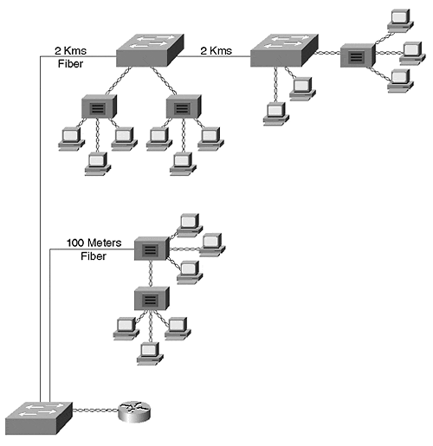

Practical Considerations
100BaseX networks offer at least a tenfold increase in network bandwidth over shared legacy Ethernet systems. In a full-duplex network, the bandwidth increases by twentyfold. Is all this bandwidth really needed? After all, many desktop systems cannot generate anywhere near 100 Mbps of traffic. Most network systems are best served by a hybrid of network technologies. Some users are content on a shared 10 Mbps system. These users normally do little more than e-mail, Telnet, and simple Web browsing. The interactive applications they use demand little network bandwidth and so the user rarely notices delays in usage. Of the applications mentioned for this user, Web browsing is most susceptible because many pages incorporate graphic images that can take some time to download if the available network bandwidth is low.
If the user does experience delays that affect work performance (as opposed to non-work-related activities), you can increase the users bandwidth by doing the following:
- Upgrading the user to 10BaseT full duplex and immediately double the bandwidth.
- Upgrading the user to 100BaseX half duplex.
- Upgrading the user to 100BaseX full duplex.
Which of these is most reasonable? It depends upon the user's application needs and the workstation capability. If the user's applications are mostly interactive in nature, either of the first two options can suffice to create bandwidth.
However, if the user transfers large files, as in the case of a physician retrieving medical images, or if the user frequently needs to access a file server, 100BaseX full duplex might be most appropriate. Option 3 should normally be reserved for specific user needs, file servers, and routers.
Another appropriate use of Fast Ethernet is for backbone segments. A corporate network often has an invisible hierarchy where distribution networks to the users are lower speed systems, whereas the networks interconnecting the distribution systems operate at higher rates. This is where Fast Ethernet might fit in well as part of the infrastructure. The decision to deploy Fast Ethernet as part of the infrastructure is driven by corporate network needs as opposed to individual user needs, as previously considered. Chapter 8, "Trunking Technologies and Applications," considers the use of Fast Ethernet to interconnect Catalyst switches together as a backbone.

Gigabit Ethernet
As if 100 Mbps is not enough, yet another higher bandwidth technology was unleashed on the industry in June of 1998. Gigabit Ethernet (IEEE 802.3z) specifies operations at 1000 Mbps, another tenfold bandwidth improvement. We discussed earlier how stations are hard-pressed to fully utilize 100 Mbps Ethernet. Why then do we need a Gigabit bandwidth technology? Gigabit Ethernet proponents expect to find it as either a backbone technology or as a pipe into very high speed file servers. This contrasts with Fast Ethernet in that Fast Ethernet network administrators can deploy Fast Ethernet to clients, servers, or use it as a backbone technology. Gigabit Ethernet will not be used to connect directly to clients any time soon. Some initial studies of Gigabit Ethernet indicate that installing 1000 Mbps interfaces in a Pentium class workstation will actually slow down its performance due to software interrupts. On the other hand, high performance UNIX stations functioning as file servers can indeed benefit from a larger pipe to the network.
In a Catalyst network, Gigabit Ethernet interconnects Catalysts to form a high-speed backbone. The Catalysts in Figure 1-9 have low speed stations connecting to them (10 and 100 Mbps), but have 1000 Mbps to pass traffic between workstations. A file server in the network also benefits from a 1000 Mbps connection supporting more concurrent client accesses.

Figure 1-9 Gigabit Ethernet Backbone Between Catalysts
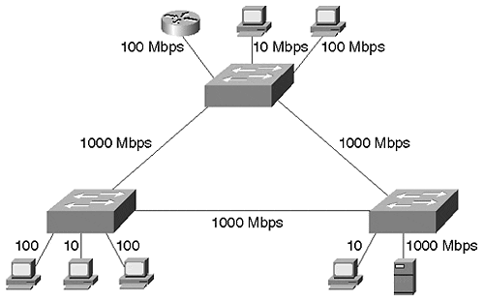

Gigabit Architecture
Gigabit Ethernet merges aspects of 802.3 Ethernet and Fiber Channel, a Gigabit technology intended for high-speed interconnections between file servers as a LAN replacement. The Fiber Channel standard details a layered network model capable of scaling to bandwidths of 4 Gbps and to extend to distances of 10 kms. Gigabit Ethernet borrows the bottom two layers of the standard: FC-1 for encoding/decoding and FC-0, the interface and media layer. FC-0 and FC-1 replace the physical layer of the legacy 802.3 model. The 802.3 MAC and LLC layers contribute to the higher levels of Gigabit Ethernet. Figure 1-10 illustrates the merger of the standards to form Gigabit Ethernet.

Figure 1-10 The Formation of the Gigabit Ethernet Standard
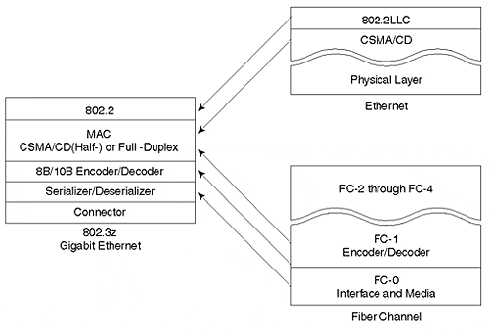
The Fiber Channel standard incorporated by Gigabit Ethernet transmits at 1.062 MHz over fiber optics and supports 800 Mbps data throughput. Gigabit Ethernet increases the signaling rate to 1.25 GHz. Further, Gigabit Ethernet uses 8B/10B encoding which means that 1 Gbps is available for data. 8B/10B is similar to 4B/5B discussed for 100BaseTX, except that for every 8 bits of data, 2 bits are added creating a 10-bit symbol. This encoding technique simplifies fiber optic designs at this high data rate. The optical connector used by Fiber Channel, and therefore by Gigabit Ethernet, is the SC style connector. This is the push-in/pull-out, or snap and click, connector used by manufacturers to overcome deficiencies with the ST style connector. The ST, or snap and twist, style connectors previously preferred were a bayonet type connector and required finger space on the front panel to twist the connector into place. The finger space requirement reduced the number of ports that could be built in to a module.
Note
A new connector type, the MT-RJ, is now finding popularity in the fiber industry. The MT-RJ uses a form factor and latch like the RJ-45 connectors, supports full duplex, has lower cost than ST or SC connectors, and is easier to terminate and install than ST or SC. Further, its smaller size allows twice the port density on a face plate than ST or SC connectors.

Full-Duplex and Half-Duplex Support
Like Fast Ethernet, Gigabit Ethernet supports both full- and half-duplex modes with flow control. In half-duplex mode, though, the system operates using CSMA/CD and must consider the reduced slotTime even more than Fast Ethernet. The slotTimes for 10BaseX and 100BaseX networks are 51.2 microseconds and 5.12 microseconds, respectively. These are derived from the smallest frame size of 64 octets. In the 100BaseX network, the slot-time translates into a network diameter of about 200 meters. If the same frame size is used in Gigabit Ethernet, the slotTime reduces to .512 microseconds and about 20 meters in diameter. This is close to unreasonable. Therefore, 802.3z developed a carrier extension that enables the network distance to extend further in half-duplex mode and still support the smallest 802.3 packets.
The carrier extension process increases the slotTime value to 4096 bits or 4.096 microseconds. The transmitting station expands the size of the transmitted frame to ensure that it meets the minimal slotTime requirements by adding non-data symbols after the FCS field of the frame. Not all frame sizes require carrier extension. This is left as an exercise in the review questions. The 8B10B encoding scheme used in Gigabit Ethernet defines various combinations of bits called symbols. Some symbols signal real data, whereas the rest indicate non-data. The station appends these non-data symbols to the frame. The receiving station identifies the non-data symbols, strips off the carrier extension bytes, and recovers the original message. Figure 1-11 shows the anatomy of an extended frame.

Figure 1-11 An Extended Gigabit Ethernet Frame
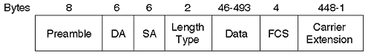
The addition of the carrier extension bits does not change the actual Gigabit Ethernet frame size. The receiving station still expects to see no fewer than 64 octets and no more than 1518 octets.

Gigabit Media Options
IEEE 802.3z specified several media options to support different grades of fiber optic cable and a version to support a new copper cable type. The fiber optic options vary for the size of the fiber and the modal bandwidth. Table 1-4 summarizes the options and the distances supported by each.

Table 1-4. Gigabit Ethernet Media Option
Standard | Cable Size (Micrometers) | Cable Bandwidth (MHz-Kms) | Distance* (Meters)
1000BaseSX | 62.5 | 160 | 220
1000BaseSX | 62.5 | 200 | 275
1000BaseSX | 50 | 400 | 500
1000BaseSX | 50 | 500 | 550
1000BaseLX | 62.5 | 500 | 550
1000BaseLX | 50 | 400 | 550
1000BaseLX | 50 | 500 | 550
1000BaseLX | 9/10 | N/A | 5,000
1000BaseLH** | 9/10 | N/A | 10,000
1000BaseZX** | 9/10 | N/A | 90,000
*Note that the minimum distance in each case is 2 meters
**Cisco capabilities that support distances greater than the 5,000 meters specified by the IEEE 802.3z standard.

1000BaseSX
1000BaseSX uses the short wavelength of 850 nms. Although this is a LASER-based system, the distances supported are generally shorter than for 1000BaseLX. This results from the interaction of the light with the fiber cable at this wavelength. Why use 1000BaseSX then? Because the components are less expensive than for 1000BaseLX. Use this less expensive method for short link distances (for example, within an equipment rack).

1000BaseLX
In fiber optic systems, light sources differ in the type of device (LED or LASER) generating the optical signal and in the wavelength they generate. Wavelength correlates to the frequency of RF systems. In the case of optics, we specify the wavelength rather than frequency. In practical terms, this corresponds to the color of the light. Typical wavelengths are 850 nanometers (nms) and 1300 nms. 850 nm light is visible to the human eye as red, whereas 1300 is invisible. 1000BaseLX uses 1300 nm optical sources. In fact, the L of LX stands for long wavelength. 1000BaseLX uses LASER sources. Be careful when using fiber optic systems. Do not look into the port or the end of a fiber! It can be hazardous to the health of your eye.
Use the LX option for longer distance requirements. If you need to use single mode, you must use the LX.

1000BaseCX
Not included in Table 1-4 is a copper media option. 1000BaseCX uses a 150-Ohm balanced shielded copper cable. This new cable type is not well-known in the industry, but is necessary to support the high-bandwidth data over copper. 1000BaseCX supports transmissions up to 25 meters. It is intended to be used to interconnect devices collocated within an equipment rack very short distances apart. This is appropriate when Catalysts are stacked in a rack and you want a high speed link between them, but you do not want to spend the money for fiber optic interfaces.

1000BaseT
One final copper version is the 1000BaseT standard which uses Category 5 twisted-pair cable. It supports up to 100 meters, but uses all four pairs in the cable. This offers another low cost alternative to 1000BaseSX and 1000BaseLX and does not depend upon the special cable used by 1000BaseCX. This standard is under the purview of the IEEE 802.3ab committee.

Gigabit Ethernet Interface Converter
A Gigabit Ethernet Interface Converter (GBIC) is similar to an MII connector described in the Fast Ethernet section and allows a network administrator to configure an interface with external components rather than purchasing modules with a built-in interface type. With a GBIC interface, the administrator has flexibility to change the interface depending upon his needs. GBIC transceivers have a common connector type that attaches to the Gigabit device, and the appropriate media connector for the media selected: 1000BaseSX, 1000BaseLX, or 1000BaseCX.

Token Ring
This chapter began with an overview of LAN access methods. To this point, you should be familiar with the various options using the CSMA/CD method. This section briefly examines Token Ring, the other popular form of LAN access.
Token Ring systems, like Ethernet, use a shared media technology. Multiple stations attach to a network and share the bandwidth. Token Ring supports two bandwidth options: 4 Mbps and 16 Mbps. The 4 Mbps version represents the original technology released by IBM. 16 Mbps, a version released after 4 Mbps, essentially works the same as 4 Mbps Token Ring and introduces a couple of optional new features to further improve the system.

Token Ring Operations
To control access onto the system, Token Ring passes a token on the network that authorizes the current holder to transmit onto the cable. Figure 1-12 illustrates a logical representation of a Token Ring system.

Figure 1-12 A Simple Token Ring Network
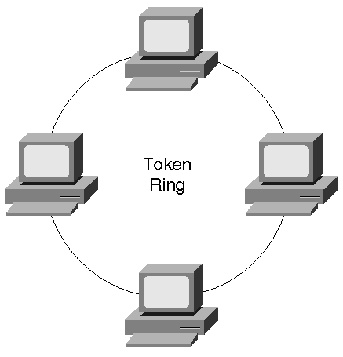
Each station in the network creates a break in the ring. A token passes around the ring from station to station. If a station desires to send information, it holds onto the token and starts to transmit onto the cable. Assume Station 1 wants to transmit to Station 3. Station 1, when it receives a token, possesses the token and transmits the frame with Station 3's MAC address as the destination and Station 1's MAC address as the source. The frame circulates around the ring from station to station. Each station locally copies the frame and passes it to the next station. Each station compares the destination MAC address against its own hardware address and either discards the frame if they don't match, or sends the frame to the processor. When Station 2 receives the frame, it too copies the frame and sends it on to the next station. All stations receive a copy of the frame because, just like Ethernet, Token Ring is a broadcast network. The frame eventually returns to the source. The source is responsible for removing the frame and introducing a new token onto the network.
In this model, only one station at a time transmits because only one station can possess the token at a time. Some network inefficiencies result, however, when a station retains the token until it removes the frame it transmitted from the ring. Depending upon the length of the ring, a station can complete transmission of a frame before the frame returns back to the source. During the time between the completion of transmission and the removal of the frame, the network remains idle—no other station can transmit. This amounts to wasted bandwidth on the network. Early token release, an optional feature introduced with 16 Mbps Token Ring, permits the source to create a new token after it completes transmission, and before it removes its frame from the network. This increases the Token Ring utilization to a much higher degree than for systems without early token release.
Occasionally, a source might not be online whenever the frame it transmitted returns to it. This prevents the source from removing the frame and causes it to circulate around the network—possibly indefinitely. This consumes bandwidth on the network and prevents other stations from generating traffic. To prevent this, one of the stations on the ring is elected to be the ring monitor. Whenever a packet circulates around the ring, the ring monitor marks a particular bit in the frame indicating, "I already saw this frame once." If the ring monitor sees any frame with this bit set, the ring monitor assumes that the source cannot remove the frame and removes it.

Token Ring Components
Token Ring systems use a hub architecture to interconnect stations. The hub, called a multistation access unit (MAU), creates a logical ring from the star attached stations as shown in Figure 1-13.

Figure 1-13 Token Ring Stations Attached to an MAU
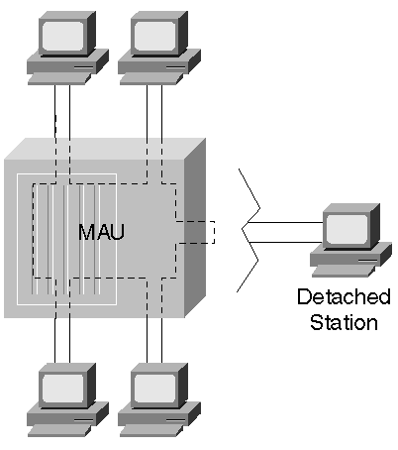
Internal to the MAU, the transmit from one station connects to the receive of another station. This continues between all attached stations until the ring is completed. What happens if a user detaches a station? When this occurs, the MAU bypasses the unused port to maintain ring integrity.
A network administrator can daisy-chain MAUs together to extend the distance and to introduce more ports in the network. Figure 1-14 illustrates how MAUs usually have ring-in (RI) and ring-out (RO) ports to attach to other MAUs.

Figure 1-14 Cascading Token Ring MAUs
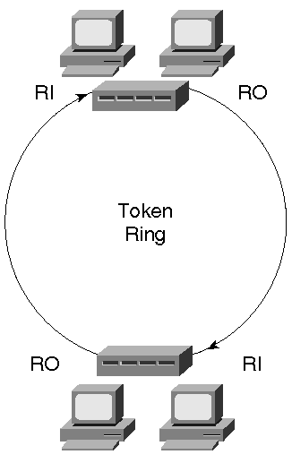

Summary
Although many of you use a number of different LAN technologies, the market still has a preponderance of legacy Ethernet deployed. A lot of 10 Mbps systems still exist with varied media options such as copper and fiber. You should expect to encounter this type of connection method for at least another few years. This chapter covered the basics of how legacy Ethernet functions.
Because of the limitations that legacy Ethernet can cause some applications, higher speed network technologies had to be developed. The IEEE created Fast Ethernet to meet this need. With the capability to run in full-duplex modes, Fast Ethernet offers significant bandwidth leaps to meet the needs of many users. This chapter discussed the media options available for Fast Ethernet and some of the operational characteristics of it.
And for real bandwidth consumers, Gigabit Ethernet offers even more capacity to meet the needs of trunking switches together and to feed high performance file servers. This chapter covered some of the attributes of Gigabit Ethernet and choices available to you for media.

Review Questions
1: | What is the pps rate for a 100BaseX network? Calculate it for the minimum and maximum frame sizes.
2: | What are the implications of mixing half-duplex and full-duplex devices? How do you do it?
3: | In the opening section on Fast Ethernet, we discussed the download time for a typical medical image over a shared legacy Ethernet system. What is an approximate download time for the image over a half-duplex 100BaseX system? Over a full-duplex 100BaseX system?
4: | What disadvantages are there in having an entire network running in 100BaseX full-duplex mode?
5: | Can a Class II repeater ever attach to a Class I repeater? Why or why not?
6: | What is the smallest Gigabit Ethernet frame size that does not need carrier extension?

